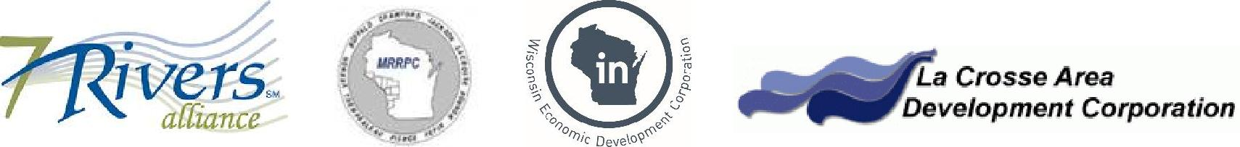

The 7 Rivers Alliance Golden Shovel Ready
Sites Submission Instructions

To submit a property for inclusion in the Gold Shovel Ready Sites Program, please follow the below steps. Note that there are no submission deadlines. Applications can be submitted at any time throughout the year.

- Complete the attached submission form and gather the requested documentation. Assemble the form and documentation into a submittal “package” labeling the requested Exhibits and placing them in the order that they are requested. Questions regarding your submission can be directed to Lisa Herr, Executive Director, The 7 Rivers Alliance, (o) 608-787-8777, (m) 608-451-5346 or lisa@7riversalliance.org

- When your submittal is ready, please submit a check for $500, payable to The 7 Rivers Alliance, along with your name, address, telephone number, and email information to:

Lisa Herr
Executive Director
The 7 Rivers Alliance
601 Seventh Street North, Suite 400
La Crosse, WI 54601

The submission form and fee of $500 per site may cover one or multiple contiguous parcels.

Do not at this point include your submittal form or any of your documentation.

Once your check has been received, you will be contacted with dropbox information so that you can electronically submit your information to the Mississippi River Planning Commission. Please make sure that your submittal is complete and organized before inserting it in the dropbox. If possible, provide the submittal form and all documentation as one file. No hard copy documents will be accepted. Questions regarding your submittal can be directed to Greg Flogstad, Director of the Mississippi River Planning Commission at 1707 Main Street, Suite 435, La Crosse WI 54601 at 608.785.9396 or greg@mrrpc.com.

- The MRRPC will review your application for completeness. You will be notified of any deficiencies. You will also be notified once your submittal is approved. Please allow a maximum of ten business days for processing.

- Once approved, your property will be entered in the State of Wisconsin’s Locate in Wisconsin property database and flagged as being Gold Shovel Ready. The 7 Rivers Alliance will provide a one page marketing strategy for your site and also market your site as Gold Shovel Ready.

- If at any point you would like modifications made to your property information please contact the Mississippi River Planning Commission at 608.785.9396 or greg@mrrpc.com. Changes made to the files after initial approval will incur a $150 processing fee that can be mailed to the 7 Rivers Alliance at the above address.

- There is also an optional annual renewal with a fee of $150 due on the anniversary of either the certification date or date of last update, whichever is most recent.

