Introduction

The 7 River’s Alliance, a regional leadership group that boosts economic growth by fostering collaboration in the Upper Mississippi Valley region, conducts an annual survey of business executives throughout Southwest Wisconsin, Southeast Minnesota, and Northeast Iowa. The data compiled in this report enables the 7 Rivers Alliance, and our partners, to accurately identify the health, confidence, ambitions, and concerns of business throughout the region. The knowledge gained through this survey will guide the direction and prioritization of future economic development projects and activities for the region.
This report summarizes the results of the 2016 Executive Business Survey conducted between April 4th and August 1st 2016. The responses of 152 participants were digitally recorded via an online survey.. Regional economic development directors led the distribution of the survey to businesses in each of the 14 counties that comprise the 7 Rivers region.
Special thanks to the following individuals for promotion of the 2016 Executive Business Survey: Terry Whipple, Juneau County, Wisconsin, Steve Peterson, Monroe County, Wisconsin,; Robin Moses, La Crosse Downtown Main Street Association, La Crosse, Wisconsin,; and Brian Fukuda, La Crosse County, Wisconsin for their assistance.

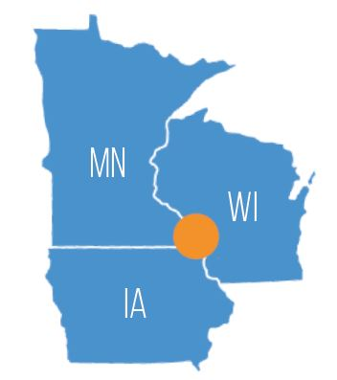

Contents
Introduction 1
Executive Summary 3
Survey Results 4
Business Satisfaction 5
Business Conditions 6
Import / Export Business 10
Future Plans 12
Business Resources 12
Sector Surveys 14
Manufacturer Survey (32 responses) 14
Retail Survey (27 responses) 16
Healthcare (5 responses) 18
Hospitality Survey (14 responses) 20
Financial Services (5 responses) 22
Observations 24
Discussion 25
Noteworthy Feedback 26
Appendix A – Technical Notes 27
Appendix B – Demographic Information 28
Appendix C – Additional Comments and Open-Ended Responses 29

Executive Summary

In 2016, The Executive Business Survey was streamlined to focus questions on priority concerns for business. The following themes were present in the results and these findings are consistent with findings in the 2014 and 2015 survey results.

Skilled Labor
A lack of accessible, skilled labor quickly emerged as the central theme of the Executive Survey. Most respondents, regardless of industry, indicated difficulties finding appropriately skilled laborers. Secondary effects of this labor shortage have the potential to permeate every aspect of operations. Unfortunately, this phenomenon is likely to continue, and may become worse. Net Migration for the State of Wisconsin is negative, meaning more people are exiting Wisconsin than entering. This trend is common throughout the Midwest. Unless communities can attract skilled workers, the labor shortage will only get worse.

Business Satisfaction
Business satisfaction is high among firms located in the 7 Rivers region. Over half of respondents graded the community as “above-average” or “excellent” in terms of amenability to business. These positive numbers are buttressed by a trend of increased satisfaction over the last three years. Trends also show an increase in business confidence, as most firms expect growth in revenue, profit, and customers in the coming year. 57% of survey participants reported plans expansion within their firm, representing a 15% increase from two years prior.

Opportunities
Even though the data relating to business satisfaction is overwhelmingly positive, there is still room for improvement throughout the region. Roughly 1 in 3 firms is operating with excess capacity in the 7 rivers region. This unrealized economic potential could detrimentally effect the region’s competitiveness. Opportunity for growth exists in trade. Roughly 5 in 6 business do not engage in international export.

Survey Results

Business owners, chief executives, and managers were the primary survey respondents. 67% of participants either owned or held a C-suite position at their firm.
Businesses targeted by the survey vary greatly in size, ranging from several hundreds of employees to those with ten or fewer. Over half of the responses were received from small businesses, with 64.6% of respondents indicating they employed 25, or fewer, individuals.
Table 1 - Percent of Respondents by Position Table 2 - Percent of Respondents by Firm Employment
Position | Percent
Owner | 46.6%
CEO or President | 21.7%
Manager | 22.4%
Personnel Officer | 3.1%
Other | 6.2%
Employee Range | Percent
1-10 | 51.7%
11-25 | 12.9%
26-50 | 10.9%
51-100 | 8.2%
101-250 | 8.8%
251-500 | 2.7%
501+ | 4.8%

The diversity among employment is also present among reported revenues. Responses for the prompt “Please select the category that best describes your company's gross sales in the past YEAR” ranged from under $25,000 to over $20 million. Nearly ¼ of respondents reported annual revenues of less than $100k.

Respondents were asked which of the given industries best describes their business. 45.8% of the executives indicated that their firm operates in the retail services and trade sector. 24.3% of respondents indicated operating a manufacturing facility.

Business Satisfaction
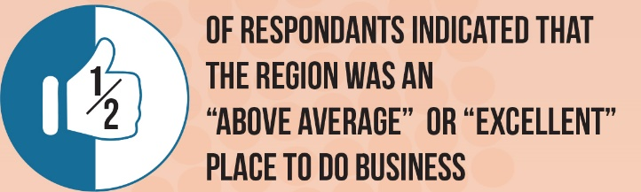
Most respondents indicated that they viewed the business environment as excellent or above average.
46.3% of the respondents indicated that the region had become a stronger place to do business over the past three years. An additional 36.1% indicated the business environment had not changed in the past three years.

Community Business Climate (3-year trend) | Percent
Got stronger | 46.3%
Stayed the same | 36.1%
Got weaker | 17.7%
Grade | Percent
A (excellent) | 14.4%
B (above average) | 43.2%
C (average) | 31.5%
D (below average) | 9.6%
F (poor) | 1.4%
Table 3 - Business Climate Trend Table 4 - Business Community Grade

Business Conditions

Over 47% of executives indicated that business activity was either strained or “just right” relative to the capacity of those businesses. Nearly one third of participants indicated that “excess capacity” best describes the current activity of their business. This finding is concerning, as “excess capacity” indicates an underutilization of the region’s economic potential.

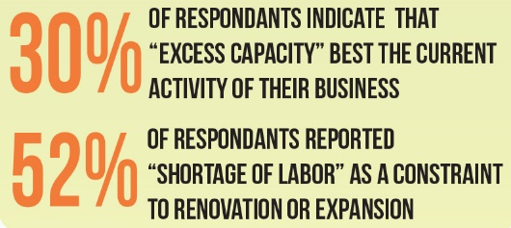
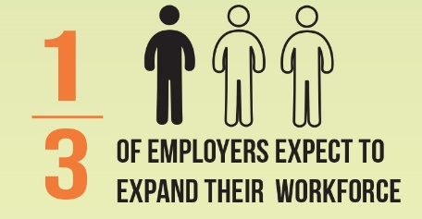
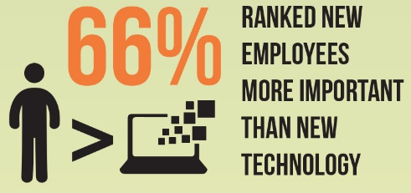

Table six (6) lists factors that businesses expect to have a major impact on their operations within the next three years. The top five influences on future business are expected to be employment/workforce, taxes/government regulation, wage rates, changing consumer tastes, and the introduction of new products. The inherent connection between wages and employment, as well as new products and consumer tastes, serves to highlight the perceived importance of these elements moving forward.
Table 5 – Future Impact, by Business Factor
Factor | Percent
Workforce | 54.5%
Taxes/Government Policy | 53.1%
Wage Rates | 40.0%
Changing Consumer Tastes | 35.2%
New Products | 33.1%
Demographics | 28.3%
Domestic Competition | 24.1%
Financing Availability | 21.4%
Transportation | 19.3%
Energy Costs | 17.9%
Raw Material Costs | 17.9%
Higher Consumer Incomes | 14.5%
New Technology | 14.5%
Foreign Competition | 9.0%
Raw Material Shortages | 6.2%
Other | 11.7%
Almost two-thirds of respondents reported expectations for increased profit and customer base over the next three years. Nearly ¾ expect an increase in revenue over the same period. These findings indicate high business confidence, while also providing evidence for a growing marketplace
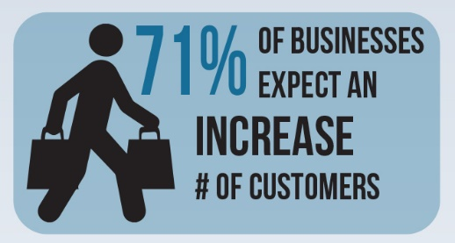
- 65.2% expect increased profits
- 74.3% expect increased revenue
- 71.0% expect an increased number of customers
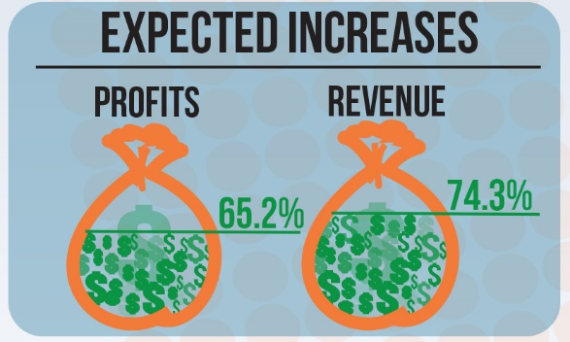
Expectations of a decline in these factors over the same time were significantly lower. Less than 5% of respondents expect a decline in customers in the next three years. Over the same period, only 5.5% expect a decline in revenue, with 12.0% also predicting a decline in profit. Low expectations of loss or downturn reaffirms the observed confidence of survey participants.
Respondents were asked to identify emerging technologies and rank the benefit of new technologies relative to new employees. Developments in computer technology and industry specific innovations were the most popular categories among those who responded to the survey. When asked if technological innovation would offer a better return on investment than new employees, 66.2% of respondents indicated “no.”
Table 6 - Predicated Technological Developments in a given field
Technological Development | Percent
Computer technology | 36.0%
Industry Specific Innovations | 25.3%
Quality Control Systems | 9.7%
Robotics | 7.5%
Routinizing Production Processes | 7.5%
New Materials | 7.0%
Lasers | 4.3%
Low Cost Substitutes | 2.7%

Table 7 - Does new technology offer better ROI than new employees?
Answer | Frequency | Percentage
No | 92 | 66.2%
Yes | 47 | 33.8%
Grand Total | 139 | 100.0%

Table nine (9) lists factors businesses consider as constraints to renovation or expansion. The two most common responses were “return on investment” and “shortage of labor,” with 48.7% of respondents indicating the former and 52.1% indicating the latter.

Table 8 – Barriers to Renovation / Expansion
Barriers to Renovation / Expansion | Percent
Shortage of adequate labor | 52.1%
Inadequate return on investment | 48.7%
Insufficient space available for expansion | 27.7%
Inability to get a loan | 20.2%
Planning and Zoning restrictions | 20.2%
Government regulation prohibits expansion | 14.3%
Shortage of adequate housing for labor | 10.9%
Environmental or Pollution Control limitations | 7.6%
Other | 19.3%

Import / Export Business
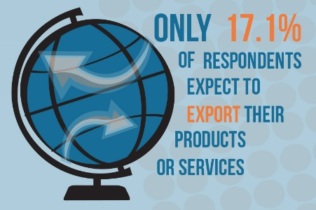
Only 17.1% of respondents indicated that their firm is currently involved in international export. distributor.

Table 10 - Is your business currently involved in international export?
Response | Frequency | Percent
No | 121 | 82.9%
Yes | 25 | 17.1%
Grand Total | 146 | 100.0%

Of those that are involved in international export, less than 5% indicated they sold over 25% of their product to distributors or final users outside of the United States. Most respondents who reported exporting goods did so directly to a final user, not a product distributor.

Table 11 - Does your business export more than 25% of its products?
Response | Frequency | Percent
No | 73 | 96.1%
Yes | 3 | 4.0%
Grand Total | 76 | 100.0%

Those who reported not exporting any products were asked to identify key factors that prevent them from conducting business outside the United States. The most reported barrier to exportation was the limited geographic scope of a firm or industry. Other respondents cited business size, language barriers, and a general lack of knowledge in exports as obstacles to international expansion.

A limited number of respondents indicated that a variety of export oriented trainings and assistance would help advance their goals of exporting their products. The distribution of these responses is highlighted in figure six (6).

Future Plans

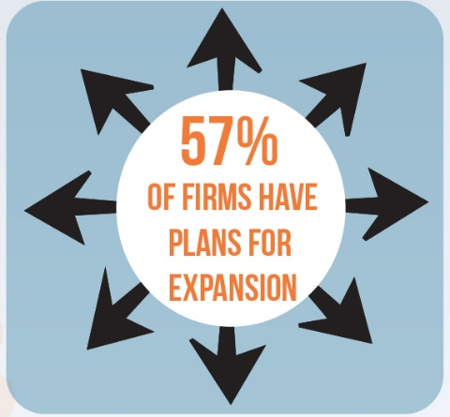
57.2% of respondents indicated their firms currently have plans for expansion. When asked more specifically about their aspirations for their business, the majority of respondents indicated that growth and stability were among the top their top desires.

Table 9 - Responses to the Question "Do you have plans for business expansion?"
Plans for Expansion | Percentage
Yes | 57.2%
No | 42.8%

Over half of the respondents specified that “market conditions” were a significant influence over a decision to move, close, or remain in the same area. Other popular responses indicate that “high local taxes” and “low worker productivity or unavailability of workers” could also place pressure on a business to move or close.

Business Resources

Approximately 1 in 3 respondents specified that their customers were their top priority among the public good, shareholders, employees, and customers. Nearly 45% of respondents indicated that they weight each category equally.

Table 10 - Percent of Respondents Indicating their Highest Priority
Row Labels | Percent
All of the Above | 43.8%
Customers | 36.1%
Public Good | 12.5%
Shareholders | 2.1%

Firms expressed interest in several business services that would aid in expansion and development. Assistance with Internet or web based services, advertisement, and free business assistance were among the most popular program areas included in the survey. Participants were given the option to rank each proposed program as potentially “useful,” “somewhat useful,” or “not at all useful.” By weighting each of these responses we are able develop a mean score, or average, of each program’s expected utility. Figure eight (8) is a comparison of the mean scores for each of the potential programs

Less Useful More Useful

Sector Surveys

In 2016 – the 7 Rivers Alliance asked sector-specific questions to provide further insight into each cluster. The Manufacturing sector had the most responses (32), followed by Retail (27), Hospitality (14), Financial Services (5), and Healthcare (5).

Manufacturer Survey (32 responses)

Manufacturers reported concerns regarding the availability of employees with appropriate skills. An increasing tax burden and over regulation were also cited as significant concerns among manufacturers.
Table 11 – Business Concerns (Manufacturing)
Field of Concern | Percent
Availability of Key Skills | 68.8%
Over-Regulation | 43.8%
Increasing Tax Burden | 37.5%
Supply Chain Disruptions | 28.1%
Geopolitical Uncertainty | 18.8%
High or Volatile Energy Costs | 9.4%
Other | 12.4%

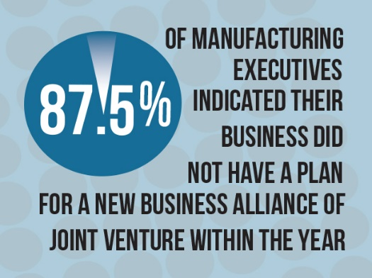

Operational improvements have benefited executives the most over the past three (3) years, as compared to supply chain management, enhancements to sourcing, and other behaviors.

Table 12 - Invest with the Best ROI.
Investment | Percent
Operational Improvements | 75.9%
Supply Chain Management | 27.6%
Enhancements to Sourcing | 24.1%
Digital Technologies | 20.7%
Other | 10.3%
Investing in Analytics | 10.3%

87.5% of the manufacturing executives indicated that their firm did not have a plan to form a new business alliance or joint venture within the year. Instead, resources seem to be focused on strategically important sectors within existing companies, such as mobile technologies, cyber security, and automation.

Less Important More Important

Retail Survey (27 responses)
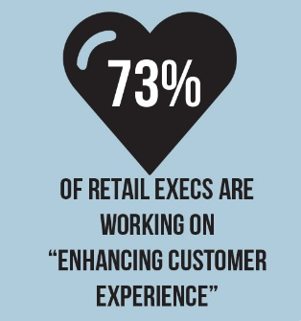
The survey responses indicate retailers are resolutely focusing on improving customer experiences as a means of increasing their revenue. In addition to managing relationships with existing customers and customer experiences, many retailers are trying to expand their scope in order to increase business. 55% of respondents reported searching for new markets for their products.

Table 13 – Behaviors to Increase Revenue
Behavior / Program | Percent
Customer Experience | 73.1%
Managing the Relationships with Existing Customers | 69.2%
Making the Next Sale | 53.9%
Employee Training | 46.2%
Increasing Brand Loyalty, Reward Programs | 15.4%
Other | 11.5%
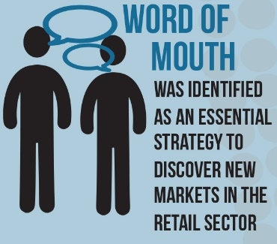
Of those searching for new markets, each firm indicated that “word of mouth” was an essential strategy through which they discovered new markets. Those who specified that they weren’t searching for new markets gave a variety of reasons, signifying that individualized problems are likely the prime barrier to growth in these instances.
Table 14 – Strategies to find new markets

Strategy | Percent
Word of Mouth | 100.0%
Online Tools | 58.8%
Professional Network | 41.2%
Online Search | 35.3%
Trade Associations | 35.3%
Financial Advisors | 0.0%
Other | 5.9%

When asked to identify the most important trends likely to develop in the retail industry over the next five years, respondents strongly indicated that enhancements to customer experiences, along with developments in personalization and customization, are the most likely areas of growth for retail businesses.

Less Important More Important

Healthcare (5 responses)

Those responding to the healthcare survey identified financial challenges, the implementation of healthcare reform, personnel shortages, and consumer satisfaction as concerning elements of their current business strategies.
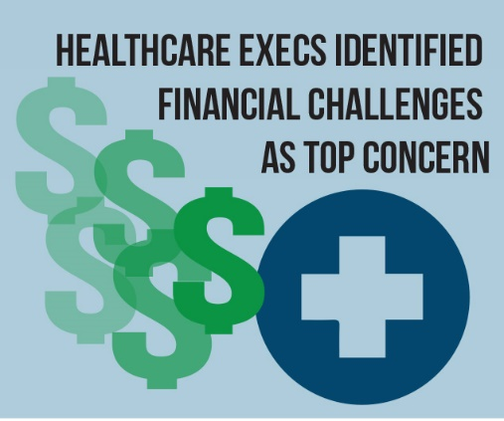

Table 15 – Percent of Healthcare Respondents Indicating Concern by Business Factor
Concern | Percent
Financial Challenges | 80.0%
Care for the uninsured/under insured | 60.0%
Healthcare Reform Information | 60.0%
Patient Satisfaction | 60.0%
Personnel Shortages | 60.0%
Governmental Mandates | 40.0%
Physician - Hospital relations | 40.0%
Population Health Management | 40.0%
Technology | 40.0%

Healthcare executives identified culture training and succession planning among their top priorities.
Table 16 - Percent of Respondents Indicating a Given Element is a Top Priority
Top Priority | Percent
Culture Training | 40.0%
Succession Planning | 40.0%
Infrastructure Technologies | 20.0%
Intergenerational Mentoring Program | 0.0%
Other | 20.0%

Executives indicated that technological advancements, home-based care, high-tech databases, and escalating prescription drug prices are likely to be the most influential factors on future business decisions.

Less Important More Important

Hospitality Survey (14 responses)
Table 17 – Program with best ROI
16
Behavior / Program | Percent
More appealing customer experience | 78.6%
Competitive Advantages | 14.3%
Managing supply chain operations | 14.3%
Data Collection | 0.0%
Other | 7.1%

78.6% of respondents in the hospitality sector indicated that the development of a “more appealing customer experience” provided the greatest ROI than any other investment in the past 5 years. 100% of hospitality executives expressed some involvement in social media as a means of marketing their business.

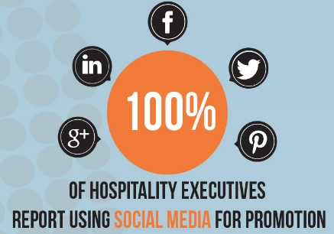
Table 18 - Industry Concerns (Hospitality)
Concern | Percent
Escalating Operating Costs | 57.1%
Changing Labor Conditions | 35.7%
Evolving Customer Expectations | 35.7%
Escalating Renovation and Construction Costs | 28.6%
Energy Costs | 7.1%
Global Uncertainty about Safety and Security | 7.1%
Other | 7.1%
Most hospitality executives expressed concern about increased operating expenses. Changing labor conditions and evolving customer preferences were also cited as concerns held by many in the industry.

Table 19 - Marketing Strategies (Hospitality)
Marketing Strategy | Percent
Social Media | 100.00%
Online Booking | 38.46%
Real Time Pricing and Room Availability | 23.08%
Other | 15.38%
Dynamic Rate Marketing | 0.00%

The concern of evolving customer taste also seems to be reflected in the ranked industry trends. The two most important trends, as indicated in the figure below, are an increased emphasis on “customer service” and “catering to millennials.” These trends, as well as the highlighted concerns, indicate that the hospitality industry is likely to focus its resources on the desires/needs of the growing population of affluent millennials.

Less Important More Important

Financial Services (5 responses)

Table 20- Participation in Certain Cyber Security Behaviors
Preparation | Percent
Educating employees at all levels about cyber attacks | 100.0%
Engaging with regulators | 100.0%
Implementing safeguards | 100.0%
Understanding the potential culprits and motivation | 100.0%

Every financial services executive indicated a myriad of actions taken within their firm to combat cyber security concerns. An aggressive expansion of cyber-crime countermeasures appears to be a high priority for financial services firms, as traditional forms of fraud and theft appear to be of little concern to industry executives.
Table 21 – Safety Concerns
Security Concern | Percent
Cybercrime | 100.0%
Accounting Fraud | 0.0%
Asset Misappropriation | 0.0%
Bribery and Corruption | 0.0%
Money Laundering | 0.0%
Other | 0.0%

When asked to identify the most important trends for the financial services sector over the next five years, executives specified customer relationships and innovative technologies as key aspects to success. In figure 14, a comparison of mean scores demonstrates this finding, as well as the limited significance financial service executives place on expanding into new markets in the coming years. Improvements to customer relationships and innovative technology were identified as the two factors most likely to influence business decisions over the next five years.

Less Important More Important

Observations

In 2016, the survey tool was modified, preventing a direct analysis of data and trends from past years. However, common themes were present in the 2014, 2015, and 2016 surveys:
- The most prevalent concerns among businesses in the 7 Rivers region are tied to employment and hiring. These concerns were emphasized in both the 2015 and 2016 executive surveys, but were absent from the 2014 survey. Since then, difficulties in hiring appear to have permeated the discussion surrounding most business decisions. Respondents have even reported considering relocation outside of the 7 Rivers Region to have access to an adequate workforce.

- Firms across multiple industries are confident about future growth. In year of the survey nearly 80% of respondents predicting an increase in revenue for the upcoming year.

- When asked to rank “the community” as a place to conduct business, respondents have consistently indicated that the 7 Rivers region is well suited to their needs. When asked to identify individual factors that make the 7 Rivers region well suited to their needs, many cited access to transportation, quality of life, access to higher education, and labor costs as highly influential. However, workforce inadequacy remained a consistent gripe among respondents.

- In recent years, a shift in the primary barrier to expansion has occurred. In the 2014 survey “no land for expansion” was the most frequent barrier to expansion among firms, with little to no mention of workforce constraints. In the years that followed, executives more frequently identified the shortage of qualified labor as a significant barrier to growth.

- Between 2014 and 2016 the number of respondents indicating their firms have plans for expansion has risen from 42% to nearly 57%. The increased number of firms planning for expansion is a strong indication of rising confidence among businesses. It is important to note that, further expansion in the 7 Rivers Region may exacerbate the workforce shortage. Or, the workforce shortage may stunt any planned expansion, thereby limiting the economic potential of the region.

- Across the years, the responses remained remarkably constant. High local taxes, lease expiration, workforce availability, and overcrowded office/building space were consistently reported as being the most significant determinants of a business’ location.

- The business climate in the 7 Rivers Region has remained satisfactory throughout the limited time of observation. Each of the surveys showed that approximately 90% of respondents felt that the business environment throughout the region was average or better. Trend data also suggests that the region is consistently developing into a better area to do business. Roughly 45% of respondents in 2015 and 2016 reported that the region had become a stronger place to do business in the previous year.

Discussion

The region’s lack of accessible, skilled labor quickly emerged as the central theme of the Executive Survey. The 7 Rivers region is in desperate need of talented, hardworking, and devoted employees to promote the expansion and development of existing businesses. This tightening of the labor force has been felt across the State of Wisconsin. Unfortunately, this phenomenon is likely to continue, and may become worse. The Wisconsin Taxpayers Alliance (WTA) predicts that to meet the workforce demands of Wisconsin businesses, the state must have a net migration of 300,000 individuals between 2010 and 2030. Data recorded since 2010 suggests that the state is now further from that goal, having lost 27,000 residents during that time. When residents move to another state both the wealth and economic impact of that individual or family is lost, thereby limiting the economic potential of the state. WTA predicts that $500 million in Income was lost in Wisconsin in 2014, based solely on the outflow of residents during that time. There is only one way to reverse this trend to meet a state’s workforce needs: attract more people. However, attracting talented individuals from other states, particularly those with families, is difficult given the climate of the Upper Midwest. This means that the amenities and opportunities provided by a region must offset the frigid winters. Historically, 7 Rivers communities have reported high levels of satisfaction concerning quality of life and community engagement. Positive scores in these metrics demonstrates that these communities have the tools needed to retain talent, but may need to further develop their plans for talent attraction. In fact, Wisconsin is fourth in the nation in population retention. Only 1.9% of Wisconsinites moved between states during 2012-2014, meaning that the state’s inability to attract new residents is partially offset by its high retention rate.

Noteworthy Feedback

Multiple respondents indicated difficulties concerning internet access, speed in their respective areas of business.

We need high speed internet! We currently have 6 slow connections that don’t meet demand.
The lack of high speed, affordable internet is affecting my ability to [do] business where I’m located.

Appendix A – Technical Notes

Technical Notes:
Each response represents one executive, not one firm. Survey requests were distributed to nearly 400 executives. Oftentimes, more than one executive of a given company received a survey request. Given our data collection methods, it is not possible to exclude any potential duplicate responses or consolidate responses from any single firm.
None of the survey questions were compulsory. Each executive was allowed to share as much, or as little, information as they deemed appropriate, consequently, the response rate for each question varies throughout the survey.
Targeted surveys are particularly susceptible to non-response bias, meaning that executives who chose not to respond to the survey may have differing views/comments than those who chose to participate.
Figures 8,10,11,12,13, and 14 display a distribution of mean scores for various questions. The responses were placed on a spectrum relating to the question at hand. By weighting each of these responses we are able develop a mean score, or average, of each responses value or potential. Each figure is a comparison of mean scores for the provided responses. A higher mean score indicates that an executive valued that response more than others.

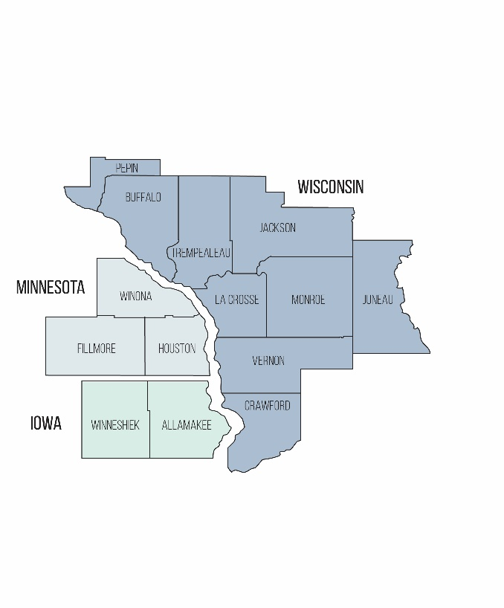
Appendix B – Demographic Information

Demographic Information
Survey requests were sent to 7 Rivers Alliance affiliates in each of the 14 counties that comprise the region targeted by the partnership. Given the voluntary nature of the survey, an accurate geographic distribution of these responses cannot be produced. Only 50% of respondents chose to indicate the County/State in which they conduct business. The distribution of the recorded responses is outlined in table one (1).

Table 21 – Number/percent of respondents by County
County/State of Business | Frequency | Percent
Juneau, Wisconsin | 30 | 39.5%
La Crosse, Wisconsin | 22 | 29.0%
Monroe, Wisconsin | 10 | 13.2%
Winona, Minnesota | 4 | 5.3%
Allamakee, Iowa | 1 | 1.3%
Winneshiek, Iowa | 1 | 1.3%
Fillmore, Minnesota | 1 | 1.3%
Houston, Minnesota | 1 | 1.3%
Crawford, Wisconsin | 1 | 1.3%

Appendix C – Additional Comments and Open-Ended Responses
The following is a full list of comments and open-ended responses organized by question.
Table 2, Question 2; What is your position in this business? (Select all that apply.)
- Business Development
- Administrator
- Clerk/Treasurer
- Gardening
- Non-Profit Board

Figure 2, Question 3; Which of the following industries describe your business? (Select all that apply.)
- Health Care and Housing for Seniors
- Entertainment
- jConvention/Entertainment Center
- Salon
- Arts and Culture
- Restaurant
- Auto Museum
- Media
- Nonprofit
- Recycling
- Chamber of Commerce
- Utility
- tourism
- Energy
- storage units
- Website Development
- alternative to sandblasting
- IT
- Painting & Staining
- Tourism/Outdoor Rec-Canoeing/Biking
- I am an inventor
- Transport trailer repairs
- Marketing agency
- health
- print corporate communications
- Campground
- Food service
- Inventor & Writer

All open ended answers or additional comments were accurately reproduced, regardless of error or intent. Responses are listed in chronological order based on the time stamp provided by the survey tool.
Table 6, Question 9; From the list below, please check the top five (5) factors likely to have a major impact on your business during the next three (3) years. (Select five)
- Development in area of business
- Transportation time
- Employee shortage
- Compeny funded health insurance
- Internet sales
- Internet competition/consumers buying online
- Parking
- Tourism
- insurance company practices
- Health of key local business including Auto, Fast Food, Telecommunications, Energy, Health and Wellness.
- cost of printed material
- New Lisbon’s City Government is not friendly to business we are very close to losing large employers to other cities
- Companies interest Sustainability with remarkable high ROI
- Patent Pending on products
- Ag technologies
- weather/ seasons
- Lack of high speed internet

Table 9, Question 13; If you face constraints on renovation or expansion, what are the top three (3) you are most worried about?
- Government reimbursement is 25% below cost, and it is our biggest payor
- population shifts
- Shortage of funding
- Workforce work ethic
- Need for business to increase
- low tourism investment
- Complacency attitude of unemployed
- Current underutilization of space
- able to work through all constraints
- Not enough biomass
- Visionless management
- Most all of the businesses in New Lisbon are frustrated with the city government primarily the Mayor take a poll of the New Lisbon business and ask them how they feel about the city
- State Budget
- Business transition options/retirement
- Marketing budget to position our revolutionary new products in the forefront of buyers
- cash flow
- no renovation/expansion planned.
- Resources to build expansion
- Childcare
- Lack of high speed internet
All open ended answers or additional comments were accurately reproduced, regardless of error or intent. Responses are listed in chronological order based on the time stamp provided by the survey tool.
Question 17; If [your firm is involved in international export], what is the nature of your involvement in international export?
- Export at the direction of a domestic customer
- tourists from other Countries
- We will be attending WEDC Export Tech this fall
- Our US distributors have many int'l customers

Figure 5, Question 18; If [your firm is not involved in international export], what prevents you from exporting your product?
- Patient care and housing services
- The museum is involved in tourism
- We are a Government Entity
- State Institution
- not specific to our type of business
- Our customers distribute Internationally
- Sell to companies that export
- Not appropriate
- very large heavy products that make shipment very costly
- service are not exportable

Figure 6, Question 19; What programs would help you export your product? (select all that apply)
- Not applicable
- Tourism dallers
- Does not apply
- Unsure
- Export Tech may provide many of these for us
- Brokers
- Does not apply
- Eliminate the EU
- Most thermoplastic components are imported. I am not aware of any that are exported.
- DO not like to export

Question 21; Do you need any assistance with any of the following? (Financial Assistance, Planning Design/Assistance, Land Acquisition, Access to Workforce, Other)
- planning & zoning
- Government needs to help with tourism $
- Selling our products
- Just need customers
- No
- Family backbone
- Legal Advice

All open ended answers or additional comments were accurately reproduced, regardless of error or intent. Responses are listed in chronological order based on the time stamp provided by the survey tool.
Figure 7, Question 22; What conditions influence your decision regarding moving, closing, or staying put?
- Building specific organization
- High federal taxes & health insurance costs
- drop in visiters
- Utility costs
- Enrollment
- We can't move. Must stimulate and maintain business within our territory
- Financial Incentive
- content with current location
- Biomass availability
- Management
- Excess costs in general
- My health (2)
- City Government
- Flood stage
- Need more business so I can quit the W-2 job and go total freelance
- Age
- Unsure
- Since our products are contracted manufactured and we have no need for a "store front" our business can be run from anywhere we have phone service and internet
- increased exposure
- sole proprietorship / retirement
- Lack of high speed internet

Table 12, Question 29; [As a manufacturer] what are you most concerned about? (select all that apply)
- Insufficient regulation
- Under-regulation
- internet speed availability
- Creating market awareness

Table 13, Question 30; [As a manufacturer] what has delivered the biggest returns in the past (3) years? (select all that apply)
- additional regulation
- On line marketing

Table 14, Question 33; [As a retailer] what are you doing to increase revenue?
- Marketing
- increasing tourests
- Aggressive pricing

All open ended answers or additional comments were accurately reproduced, regardless of error or intent. Responses are listed in chronological order based on the time stamp provided by the survey tool.
Table 15, Question 35; [As a retailer looking to find new markets], what strategies are you using to identify new markets?
- La Crosse Area Convention and Visitors Bureau

Question 36; [As a retailer not looking to find new markets], why not?
- Lack of employees availabile in this area
- Dealer agreements prohibit solicitation outside territory
- AS A RETAILER I NEED CUSTOMERS
- Wanting to sell and retire
- Does not apply

Table 17, Question 40; [As a healthcare executive] what are your top priorities over the next five (5) years preparing your organization for the future?
- Adapting to Medicare payment model changes

Table 18, Question 42; [As a hospitality executive] what delivered the biggest returns in the past five (5) years?
- Getting consumers to understand parking downtown

Table 19, Question 43; [As a hospitality executive] How are you currently marketing your service?
- Radio
- Printed Materials

Table 20, Question 44; [As a hospitality executive] what are you most concerned about? (select all that apply)
- Local Government

All open ended answers or additional comments were accurately reproduced, regardless of error or intent. Responses are listed in chronological order based on the time stamp provided by the survey tool.

Assigned Weight: “useful” = 2, “somewhat useful” = 1, and “not at all useful” = 0. The count for each response type is multiplied by the appropriate factor, then divided by the total number of responses to calculate an average.
June 2016. The Wisconsin Taxpayer. Vol.84, #6/7. The Wisconsin Taxpayers Alliance

