2018 Executive Survey Results
Total Responses | 53
Responses in Manufacturing | 8
Responses in Healthcare | 7
Responses in Financial Services | 4
Responses in Retail | 6
Responses in Hospitality/ Food Services | 2

- Business Climate
Which of the following best describes the 7 Rivers Region as a place to do business?
Excellent 32.1%
Above Average 43.4%
Average 22.6%
Below Average 1.9%
Poor 0%
In the last year, did the 7 Rivers Region become a better place to do business, a worse place to do business, or has no change occurred?

Better 43.4%
Worse 7.5%
No Chance 49.1%
In the following categories, please mark if you expect an increase, decrease, or no change in the coming year.

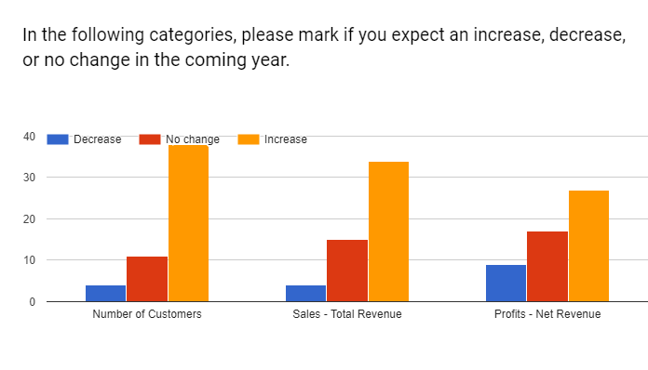
Number of Customers
Decrease 4
No Change 11
Increase 38
Sales – Total Revenue
Decrease 4
No Change 15
Increase 34
Profits – Net Revenue
Decrease 9
No Change 17
Increase 27
How would you rate the economic strength of the 7 Rivers Region?
Excellent 18.9%
Above Average 50.9%
Average 30.2%
Below Ave/Poor 0%
How would you rate the economic strength of your company?
Excellent 20.8%
Above Average 47.2%
Average 26.4%
Below Ave 3.8%
Poor 3.8%

- Infrastructure
Do you have access to high speed internet?
Yes 98.1%
No 1.9%
Are you satisfied with the speed and reliability of your current internet service?
Yes 84.9%
No 15.1%
What level of impact does reliable internet service have on the efficiency of your business?
High Impact 84.9%
Some Impact 13.2%
Not sure 1.9%

How satisfied is your business with the following transportation systems?
Local Roadways
Dissatisfied 19
Neutral 13
Satisfied 19
Not Applicable 2
State and Federal Roadways
Dissatisfied 11
Neutral 13
Satisfied 26
Not Applicable 3
Commercial Air Service
Dissatisfied 8
Neutral 16
Satisfied 14
Not Applicable 14
Barges/Waterways
Dissatisfied
Neutral 16
Satisfied 15
Not Applicable 22
- Business Conditions
Which of the following best describes your company’s business activity?
Too much business; capacity is strained 30.2%
Business activity is just right 45.3%
Too little business; excess capacity 30.2%
Do you expect to create new positions in the coming year?
Yes 48.1%
No 51.9%
Has your company had trouble finding qualified workers in the past year?
Yes 66%
No 34%
If yes, at which skill levels/job qualifications? (Select all that apply) (37 Responses)
Professionals 51.4%
Managers, Administrators, Supervisors 45.9%
Office Workers 43.2%
General Skilled Workers/Laborers 56.8%
Entry Level Workers 54.1%
In the following categories, please mark if you expect an increase, decrease, or no change I the coming year.
Seasonal Employees
Increase 11
Decrease 2
No Change 39
Part Time Employees
Increase 18
Decrease 3
No Change 31
Full Time Employees
Increase 21
Decrease 3
No change 28
In the list below, please rank each factor based on its expected impact on your business over the next three years.
Workforce Availability
High Impact 28
Some Impact 10
Low Impact 8
No Impact 2
Unsure 4
Changing Consumer Tastes
High Impact 13
Some Impact 23
Low Impact 9
No Impact 8
Unsure 0
Domestic/Foreign Competition
High Impact 4
Some Impact 8
Low Impact 10
No Impact 28
Unsure 3
Raw Material Costs
High Impact 11
Some Impact 10
Low Impact 10
No Impact 17
Unsure 5
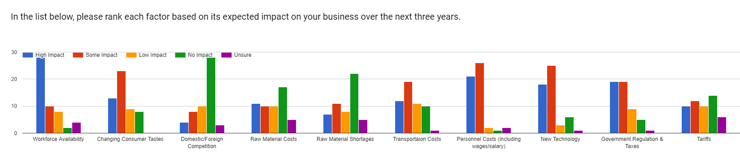
Would you be willing to subsidize employee childcare if it would guarantee availability?
Yes 13.2%
No 34%
Maybe 52.8%
Does your company offer programs to help offset the cost of child care?
Yes 20.8%
No 79.2%
If yes, what type of programs do you offer? 11 responses
Flex Spending 7/11 = 63.6%
Lower Childcare rate on campus – 1 repsones
Flexible Hours – 1 Response
What percentage of your employees received a raise in the previous year?
0% 3
- 6
25-49% 0
50-75% 9
75 – 100% 27
From the factors below, what does your company consider to be significant barriers to growth or expansion? ( Select all that apply?)
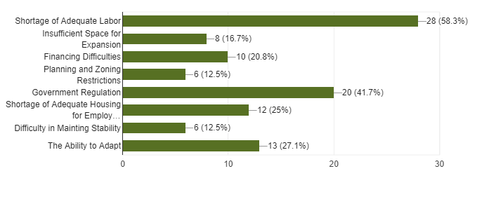
How concerned are you about tariffs impacting your business?
Very Concerned 23.1%
Somewhat Concerned 36.5%
Not Concerned 40.4%
Did your company benefit from the tax reform package passed by Congress this year?
Yes 38.5%
No 40.4%
N/A 21.2%
If so, how do you plan to use the additional money? Please check all that apply (39 responses)

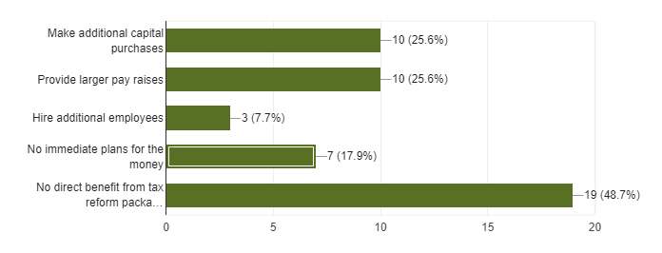
- EMPLOYEE CONDITIONS
Please rank these challenges, in order of severity, faced by your employees. (1-4)
Affordable Housing
- 1 (9)
- 2 (19)
- 3 (8)
- 4 (14)
Affordable Health Care
- 1 (23)
- 2 (8)
- 3 (8)
- 4 (11)
Transportation Access
- 1 (6)
- 2 (11)
- 3 (14)
- 4 (18)
Affordable Childcare
- 1 (11)
- 2 (12)
- 3 (20)
- 4 (7)
In your opinion, does the 7 Rivers Region offer affordable, equitable housing?
Always 14%
Sometimes 82%
Never 4%
What is your opinion of housing development in the 7 Rivers Region?
Too much development is occurring 0%
There is an appropriate amount of housing 42.9%
Too little development is occurring 57.1%
How would you rate the ability of employees at your company to identify challenges related to business operations of processes?
Excellent 12%
Above Average 32%
Average 40%
Below Average 16%
Poor 0%
How would you rate the ability of employees at your company to solve problems?
Excellent 17.3%
Above Average 51.9%
Average 26.9%
Below Average 3.8%
Poor 0%
How would you rate the work/life balance of employees at your company?
Excellent 15.4%
Above Average 36.5%
Average 32.7%
Below Average 13.5%
Poor 1.9%
- TRADE
Is your company currently involved in international trade?
Yes 13.2%
No 86.8%
If no, what is preventing your company from expanding into foreign markets?
Business is designed to serve a specific area 89.7%
Lack of Export Knowledge 5.1%
Costs are too high 2.6%
Tough Competition 2.6%
Is your company looking to expand into export markets in the next 12-14 months?
Yes 4.1%
No 93.9%
Maybe 2%
OPEN ENDED QUESTIONS
What is your firm’s biggest challenge or obstacle right now?
Anti-Government sentiment
Lack of qualified applicants
Employees
Budgets are decreasing - we are a government agency
finding employee
recruiting and keeping qualified employees
Aging workforce
Changing technology
Changing trends in the market/becoming obsolete because of technology
workforce shortage
Management and long-term strategic planning
Utility costs
Finding new customers
Healthcare reimbursement
Succession. Finding person to take over company
reimbursement issues
Trade uncertainty among our largest customer segments, the auto industry.
Tariff's imposed and oversupply of ag commodities
Corporate national expansion is limiting focus on our operations in La Crosse
How to get the people (mostly White People) who really can benefit from an education series about privilege, equity and social justice to attend, participate and consider new options to take action in the future when thinking about non-White individuals.
Lack of housing inventory to sell
sales
hiring enough employees
Cash flow and finding dependable skilled workers
Levy limits, lack of local funding options for providing services
Costing heath coverage out of control
Economic stability in the USA
Finding good team members and retaining them
Levy limits
Government regulations and political decisions
staffing
Government regulation
Volunteer engagement
CASH FLOW
Sales
Staffing
Finding qualified workers.
Space and market changes
This area not attractive to talent due to lack of medium income housing
Getting more long customers
High income over living expenses
housing

What trend in your industry is most likely your impact your future business?
lack of honesty, culture of ridiculousness
UI Rate going up
budgets
tarriff
recruiting and keeping qualified employees
Technological changes
Renewable Energy
technology
workforce
Consumer habits
Utility costs
Lack of skilled trades people - i.e. machinists
Shift in payment structure
Technology, Lack of small business owners/operators
healthcare mergers
Offshoring
consolidations and capital requirements
Streaming content, both opportunity and challenge
Technology advances
Rising interest rates
uncertainty in the international market place
Minnesota legislative issues/staffing
Trump's leadership will lead to a depression
Levy limits, lack of local funding options
Worker shortage
Financial markets improvement / interest rates stability
Wage inflation and getting people to work in manufacturing
Continued levy limits
lack of staff
technology - internet of things
Rates
Technology
LOW AGRICULTURAL COMMODITY PRICES
Energy efficiency
Changing customer base and preferences
Lack of qualified workers.
Tariffs
telework rather than travel and face to face meetings, a negative trend
Ordering online
More and more computerized work
lenders

What tactics does your firm employ to promote business and expand into new markets?
facebook, newsletter,
Many
use of electronic media
hired salesperson
advertising differently than in the past
Outreach to likely clinets
TV, Mail, internet
Advertising, invitations, social media,
training, surveys
Social Media
Make opportunities available to our businesses in the Village
Internet Marketing
Transparency
Internet
n/a
We employ a business development manager.
aquisitions
Buy companies, invest resources
A personal approach
Educational workshops/educational press
Internet marketing
active sales prospecting program
we are not expanding
Word of mouth, advertising, social media, radio interviews
NA
Visual marketing , community support .
Networking
Direct Sales force, Independent rep firms, internet, google addwords
None
great marketing communication to stakeholders
Acquisition
Addressing labor shortage issues
ONLINE, PERSONAL SALES
Social media
Internet marketing
We are very word of mouth, facebook and our newsletter are important with a smattering of radio, flyers, posters and newspaper.
social media marketing
Webinars, telephone outreach, some live events
lots of advertising to get the word out about our business
social media
none
advertising

Would you be interested in having a local economic development professional meet with you to learn about your needs, and how they can be of support? If yes, who should we contact?
sure -- Mark Glahn
Mary Jo Hill
maybe. contact Hank Kokke; hank@ssmp.net
Jason Gilman or Andrea Schnick
Yes, Cary Winch
Sheila Marx
I'm taking a Co-Starters course in starting a business but have little legal protection and little money to protect my ideas.
Part 2: Sector Specific
52 Responses
Finish Survey 46.2%
Manufacturing 15.4%
Retail 13.5%
Hospitality/Food Service 3.8%
Financial Services 7.7%
Healthcare 13.5%
Manufacturing
What types of products does your firm manufacture?
automation equipment
Injection Molding Services
Service-Real Estate
Plastic Mold Tooling
precision thermoplastic injection molded parts
Idenity signs
Printed labels, overlays and printed electronics
electric motors
Camping trailers

What do you believe is the biggest concern facing your firm?
Worker Shortage 62.5%
Geopolitical Uncertainty 25%
Supply Chain Disruptions 12.5%

Please identify a practice/behavior that has delivered the biggest returns in the past three years.
Operational Improvements 44.4%
Digital Technologies 22.2%
Hire Sales Person 11.1%
More emphasis on marketing and sales 11.1%
Development of new product line for appliance industry 11.1%
Does your firm have any plans to form a new business alliance or joint venture within the next year
No 77.8%
Yes 11.1%
Maybe 11.1%
What do you think is the most strategically important for your business in the next 5 years? 1- high, 5 least)
Cyber Security 5
Mobile Technologies for Engaging Customers 2
Robotics of Products and Services n/a
High or Volatile Energy Costs 4
RETAIL
What is the most important to increasing revenue?
Customer Experience 46.2%
Making the next sale 7.7%
Employee training 7.7%
Increasing Brand Loyalty, reward programs, relationships 7.7%
Marketing, awareness, deals 23.1%
Invention of new products 7.7%
Is your firm currently looking for new markets?
Yes 78.6%
No 21.4%
If yes, what kind of market?
The use of robots
Commercial Sale-On Line Real Estate
Manufacturing Consulting
new customer base markets
Selling a new product to existing markets
Volume buyers
identifying trends
millennials in manufacturing
local

If no, why not?
Resources 66.7%
Struggle to find reliable partners or investors 33.3%
If yes, what strategies are you using to identify new markets?
Professional Network 27.3%
Trade associations 18.2%
Word of Mouth 9.1%
Online Tools 45.5%
What are the most effective strategies in the retail industry in the next 5 years?
Enhancing Customer Experience 1
Personalization of products and services 2
Giving Consumers more payment options 5
Adopting in-store mobile devices 3
Hospitality/Food Service
What has delivered the best returns in the past 5 years?
More appealing customer experience 100%
What are the most effective marketing strategies used by your organization
Social Media, You ask strategies (plural), but only allow one answer. A combination of social media, paired with our dynamic website and regular newsletter seem to deliver the biggest punch for the money
What are the biggeset concerns facing growth to your organization? Check all that apply.
Changing labor conditions, Energy Costs
Which trends are going to be most important to your organization when making future business decisions (1 – important 5 not)
Customer service
Financial Services
What are the top challenges facing banks and financial institutions?
Regulatory Pressure, Satisfying more demanding customers
What practice/behaviors does your organization regularly engage in to combat cyber security? Check all that apply.
Implementing Safeguards, engaging with regulators, educating employees at all levels
What is your organization’s top safety concern?
Cybercrime, accounting fraud
Which trends do you believe will become most important to success in your industry over the next 5 years? (1 important)
Customer Relations, new markets, innovative technology
Healthcare
What are you most concerned about?
Financial Challenges
Healthcare reform information
Patient satisfaction
Personnel shortages
Government Mandates
Technology
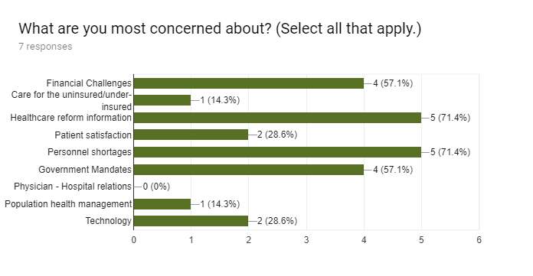
On a personal level, what is your biggest challenge?
Finding and recruiting top talent 71.4%
Adaptability 14.3%
Meeting Customer Expectations 14.3%
What trends are going to be most important to your organization when making future business decisions?
Escalating drug prices, Technological Advancements, Healthcare moving to the home, high-tech databases
Email List
JMITCHELL@ABLE-INC.ORG
jschwaba@smumn.edu
amy@trempealeauhotel.com
bwburg@centurytel.net
craigp@plasticert.com
dirtyturtle@dirtyturtle.com
dlvest97@gmail.com
dm4m2004@yahoo.com
fern.rissman@iwd.iowa.gov
hank@ssmp.net
jbeck@fox2548.com
kabatt@cityoflacrosse.org
kdahl@mwt.net
kendallvill@centurytel.net
mark.glahn@expresspros.com
mary.kessens@aptiv.org
maryjo@wifirstchoicerealty.com
maryradl@alliantenergy.com
news@q102wvrq.com
paulf@lacrossesign.com
peter.johnson@duratech.com
rbenson@peoplesfinancial.com
reva.witte@regalbeloit.com
timk@statebankfinancial.com
tschnitzler@westsalemwi.com
tthompson@tomanwisconsin.com

Feedback
Look forward in seeing the results.
I appreciate your efforts to continually improve what is already an amazing region to live and do business in. Thank you.
I did not know this group existed until a LinkedIn follower posted the survey.
Survey didn't quite apply to my specific business but is well designed.
this was longer than I hoped it would have been.
thanks for compiling this input
Doesn't seem to fit local government
I would be helpful to understand the number of people working in human service in the 7 Rivers region and how to support their continued impact. The cost of loss of human service organizations due to lack of funding will make it even more difficult for other businesses to make up the loss.
I appreciate that you create this survey. It seems to evolve each year and that is important. Asking about the effect of the "tax break" is great, but there was nothing asked about how we think our customers feelings about the current political climate effect their decision business/decision making. For example, I am not sure how to word it, but some people in the bar business think they are so busy because people are depressed and entirely uncertain about their future (and that of their country, the elderly, infrastructure, education...). Some people are getting out of the stock market (while clearly, others buy in), some take out loans as they think the days of low interest are over. Many are not investing in solar as the breaks for doing so are gone. I own a restaurant. The fires raging in California as well as the lack of workers to pick crops have contributed to a 30% increase in my raw ingredients in one calendar year. I cannot command a 30% price increase on my menu. Again, thank you for taking the time to do this.

