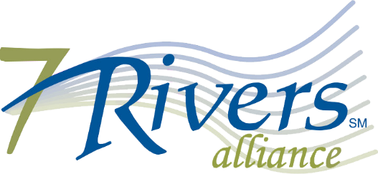
2020 INVESTOR & MEMBER RENEWAL

2020 Investor/Member Fee
(Membership from January through December) Invoice #: $

SPONSORSHIP OPPORTUNITIES

PAYMENT INFORMATION

☐ Payment enclosed. Make check payable to The 7 Rivers Alliance.
☐ Check
☐ VISA ☐ MASTERCARD
Credit card # ____________________________________ Exp.Date _____/____ CCV:_______
Cardholder’s name (print) _______________________________________________________
www.7riversalliance.org
info@7riversalliance.org
7 Rivers Alliance
601 7th St N, Ste. 400
La Crosse, WI 54601
608-787-8777

